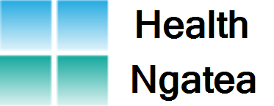
HEALTH NGATEA NEWSLETTER – OCTOBER 2023
Greetings to our Community,
October is Breastscreening Awareness Month and we are pleased to confirm that the Midlands Breastscreen Aotearoa Mobile Unit, will be in Ngatea from 10th November to 1st December. They will be located in the rear carpark behind our Practice. We are currently contacting all women who are eligible for this free service to enroll you in the National Breastscreening Programme. We will either ring you or send a text message over the next few weeks if you haven’t heard from us already. Alternatively, you can phone them directly on 0800 270 200.
Breast cancer is the most common cancer diagnosed in New Zealand. Each year, over 3000 women and 25 men are diagnosed with this disease. In kiwi women, we have an average lifetime risk of 11% or ( 1 in 9 ) chance of developing breast cancer. The risk increases with age and approximately 75% of all breast cancers are diagnosed in women 50 years and over.
Only 5-10% of breast cancers are inherited, most commonly because of a BRCA1 or BRCA2 gene mutation.
BREAST CHANGES TO SEE YOUR GP ABOUT
. A new lump or thickening, especially if it is only in one breast
. A change in breast shape or size
. A pain the breast that is unusual
. A change in the skin of the breast ie. Puckering or dimpling, reddening or a rash
. Any change in nipple such as a turned-in nipple, or discharge that occurs without squeezing
BREAST SCREENING
. Free Mammograms for eligible women aged 45-69
. Have had no symptoms of breast cancer
. Have not had a mammogram in the last 12 months
. Are not pregnant or breastfeeding
. Are eligible for Public Health Service in New Zealand
. Free of breast cancer for 5 years
Early detection is your best protection. It increases your chances of surviving breast cancer and living a healthy life. For more information visit: www.timetoscreen.nz

Team Health Ngatea

